mini unit plan – year one – digital technologies
Graphing Warriors

ABC School
Designed to Align with Australian Curriculum Digital Technologies

Mini Unit Plan: Graphing Warriors
Year Level: 1
Digital Technologies
In this week long mini unit plan, students will be shown various ways in which data can be collected, recorded and represented.
They will utilise and access prior knowledge of basic mathematical concepts, skills and processes which were developed during the Early Years Learning Framework.
This resource has been designed to meet the requirements of the following Australian Curriculum Technologies Strand and also incorporates parts of critical and creative thinking, ICT capabilities and literacy and numeracy general capabilities.
Digital Technologies Knowledge and Understanding: Recognise and explore patterns in data and represent data as pictures, symbols and diagrams (ACTDIK002)
Elaborations
- sorting objects and events based on easily identified characteristics and using digital systems to represent patterns in data, for example sorting birthdates and presenting the patterns using seasonal symbols
- experimenting with different ways of representing patterns, for example using materials, sounds, movements or drawing
Digital Technologies Processes and Production Skills:
Collect, explore and sort data, and use digital systems to present the data creatively (ACTDIP003)
Elaborations:
- collecting, and sorting data through play, for example collecting data about favourite toys and sorting them into categories such as toys they like or dislike
- exploring and creating graphs to represent classroom data, for example collecting data on the country of birth of each student and presenting the results as a picture graph
- using common software to present data creatively, for example as a slideshow, movie, sounds, image, chart, word art, poster or drawing

Resource Outline
Summative Assessment …………………………………………………………………………Page 1 – 2
Rubric……………………………………………………………………………………………Page 3
Unit One Lesson One……………………………………………………………………………Page 4 – 6
Unit One Lesson Two…………………………………………………………………………...Page 7 – 10
Unit One Lesson Three………………………………………………………………………….Page 11 - 12
Unit One Lesson Four …………………………………………………………………………..Page 13 - 14
Unit One Lesson Five …………………………………………………………………………..Page 15 - 16
Extra Worksheets………………………………………………………………………………..Page 17 – 25
SUMMATIVE ASSESSMENT PIECE
The below table shows the favourite fruits of a class of children
Grapes | 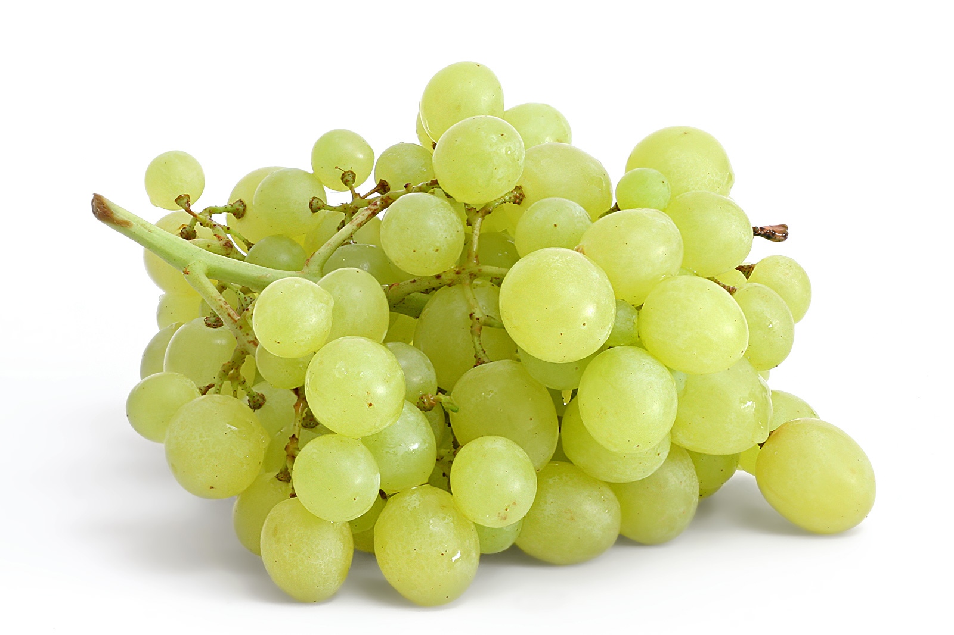
Strawberries | 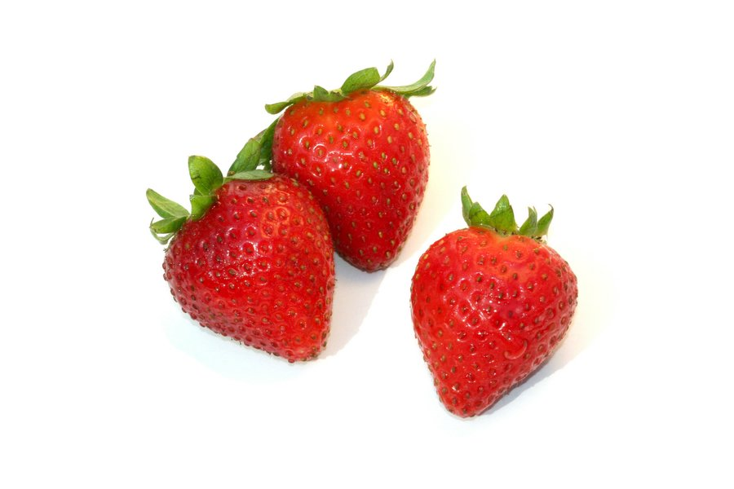
Bananas
Cherries
apples | 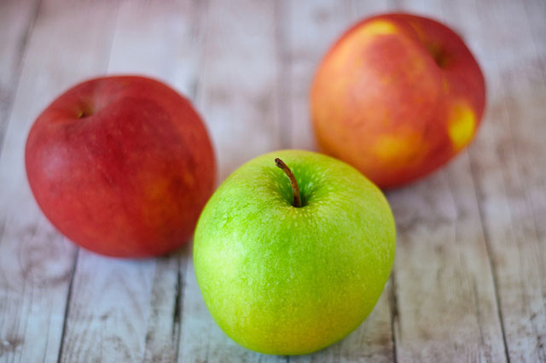

Question 1) How many students favourite fruit was:

….................. ………………….. ………………….. ……………… ………………

Question 2) On a blank piece of paper show another way to graph the below data:
5
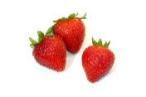8
4

Question 3) WRITE ANSWER DRAW ANSWER
The most popular fruit is

The least popular fruit is

More people chose bananas over

My favourite fruit was

Question 4) If you had to design your own graph what would it be on and what questions would you ask? (This question can be verbally assessed by teacher or teacher aide)
RUBRIC
 | High | Sound | Developing | Support Required
MAKING CONNECTIONS | Student can independently make connections between gathered information and data representation | Student can identify most of the connections between gathered information and data representation | Student is beginning to independently make connections between gathered information and data representation | With support student is beginning to make connections between gathered information and data representation
REPRESENT DATA | Student can independently represent data with objects and drawings | Student can represent most data with objects and drawings | Student is beginning to independently represent data with objects and drawing | With support student is beginning to represent data with objects and drawing
DESCRIBE DATA | Student can independently describe and compare different data representation | Student can describe and compare most data representation | Student is beginning to independently be able to describe and compare different data representation | With support student is beginning to describe and compare different data representation
GENERATE QUESTIONS | Student can independently generate questions and accurately gather responses for data representation | Student can generate some questions and gather responses for data representation | Student is beginning to independently generate questions and accurately gather responses for data representation | With support student is beginning to generate questions and accurately gather responses for data representation

Year One Digital Technologies
Unit One Lesson One
Materials | Interactive Resources | General Capabilities / Cross Curriculum Priorities | Assessment | Differentiation
Whiteboards  Pens  Pencils  Student Workbooks  Access to Internet | Picture Graphs | Numeracy  Literacy | Completion of worksheet  Anecdotal evidence of discussions  Observation of student participation and understanding | Provide students a sheet with months of the year on it for support  Students will be given extra time to complete work if required.  Seating arrangements can be changed to allow enhanced visual and hearing access  Extra scaffolding and support provided by teacher and teacher aide if required.
Lesson One
Introduction ( 5 mins )
- Teacher will initiate discussion about similar characteristics throughout the classroom (shoe colour, skirt/pants, boys/girls)
- Ask the students what can we do to represent this information in an easier way so we can access it quickly if need be?
- As a class discuss the different ways (Group students/ draw pictures)
- Model how to complete a picture graph using a range of questions ( favourite food, pets )
Body ( 25 mins )
- Ask the students a method we could use to display everyone in the class’s birthday – Listen to the answers and facilitate discussion. Ask the students if they have ever heard of a picture graph and what they think it is.
- Teacher will then show the students the YouTube clip on Picture Graphs
- Get the students to write all the months of the year in their workbook (teacher to model how this is to be done) then one by one get the students to announce their birthday month and draw a present under the month to represent each one. Once completed, as a class interpret the data together.
Conclusion ( 10 mins ) - REMIND STUDENTS TO KEEP A DIARY OF THE DINNER
- Get the students to complete the below worksheet as a formative assessment piece
Birthday Data

Student Name…………………………………
Which month of the year has the most birthdays?..............................................

Which month of the year has the least birthdays?...............................................

Is there any months of the year which have the same amount of birthdays? YES OR NO

Write down which months……………………………………………………………………

In the box below draw a picture to represent the amount of birthdays in your birthday month

Year One Digital Technologies
Unit One Lesson Two

Materials | Interactive Resources | General Capabilities / Cross Curriculum Priorities | Assessment | Differentiation
Whiteboard  Pens  Paper  Access to Internet  Tally O’Mally Book | Tally O’Mally  Tally Marks Train | Numeracy  Literacy  Critical and Creative thinking | Completion of worksheet  Anecdotal evidence of discussions  Observation of student participation and understanding | Students will be given extra time to complete work if required.  Seating arrangements can be changed to allow enhanced visual and hearing access  Extra scaffolding and support provided by teacher and teacher aide if required.

Lesson Two
Introduction ( 5 mins )
- A discussion will be facilitated by the teacher about what things we can graph and the ways in which we can represent it.
Body ( 25 mins )
- Following on from the birthday data the teacher will get the students to draw on a blank piece of paper a picture representing their birthday
- These pictures will then all be collated and placed into a bar graph on the classroom floor.
- The birthday data can also be represented using different coloured lego for a three dimensional bar graph
- The students will then discuss whether this data is similar to the birthday picture graphs – then discuss how collected data represented differently still provides the same information.
- Show the students how to represent data by tallying. Tally the birthday data into a graph, and ask the students if they can see what happens when you get to number 5. Watch the attached clip on tally marks
- The teacher will now read the book Tally O’Mally ( If a hard copy isn’t available, teachers can access the youtube clip of Tally O’Mally)
- The students will now be given a worksheet (next page) to complete on the book Tally O’Mally. The teacher is required to read the pages as per the worksheet but not give answers.
Conclusion ( 10 mins ) - REMIND STUDENTS TO KEEP A DIARY OF THE DINNER
- As a class, go through the answers on this worksheet once this is completed students chose a partner and complete the next worksheet.
Tally O’Mally

Name:………………………………………………

Look at the tallies on page 14
How many silver cars did Eric see?........................................................................
How many red cars did Neil see?..........................................................................
How many blue cars did Bridget see?...................................................................

Turn to the tallies on page 22
How many yellow shirts did Eric see?....................................................................
How many red shirts did Neil see?........................................................................
How many green shirts did Bridget see?..............................................................
DIRECTIONS: With your partner, walk around the room and count the objects you see. Write the correct number of tally marks for each object.

OBJECTS | TALLY MARKS
Tables / Desks

Windows

Chairs

Doors

Whiteboards

Reading Books

Name:………………………………………………………

Name:………………………………………………………

Year One Digital Technologies
Unit One Lesson Three

Materials | Interactive Resources | General Capabilities / Cross Curriculum Priorities | Assessment | Differentiation
Whiteboard  Pens  Paper  Access to Internet  IPAD |  | Numeracy  Literacy  Critical and Creative thinking  ICT Capabilities | Completion of poster  Anecdotal evidence of discussions  Observation of student participation and understanding | Students will be given extra time to complete work if required.  Seating arrangements can be changed to allow enhanced visual and hearing access  Extra scaffolding and support provided by teacher and teacher aide if required.

Lesson Three
Introduction ( 5 mins )
- Facilitate a class discussion on what we have learnt so far this week. Observe students current understanding and knowledge and make notes on topics that need to be revisited.

Body ( 30 mins )
- At the end of the previous lesson, students were required to complete a worksheet in pairs displaying the correct number of tally marks for the object.
- As a class go through and discuss these answers, ask the students to write the correct numeral next to the tally marks
- Get the students to all sit in a circle on the floor, using the IPAD get each student to take a photo of the person to their right.
- Bring these pictures up on the whiteboard for the class to see.
- Looking at the pictures, make a list of the different things you could graph ( hair colour, eye colour, boy/girl)
- Using one of the variables determined by the class, get the students to create their own poster showing the variables from the images displayed on the white board.
Conclusion ( 5 mins ) - REMIND STUDENTS TO KEEP A DIARY OF THE DINNER
- Discuss the possible answers as a class
Year One Digital Technologies
Unit One Lesson Four
Materials | Interactive Resources | General Capabilities / Cross Curriculum Priorities | Assessment | Differentiation
Whiteboard  Pens  Paper  Access to Internet  IPAD  Journals  Colouring Pencils | Photosnack | Numeracy  Literacy  Critical and Creative thinking  ICT Capabilites | Presentation of dinner activity  Anecdotal evidence of discussions  Observation of student participation and understanding | Students will be given extra time to complete work if required.  Seating arrangements can be changed to allow enhanced visual and hearing access  Extra scaffolding and support provided by teacher and teacher aide if required.

Lesson Four
Introduction ( 5 mins )
- At the beginning of this unit students were advised that they would need to keep a record/journal of dinners they have eaten over the past week.
- As a class go through each student one at a time and get them to tell the class one meal they have eaten over the week
- Once each student has had a turn ask the students if they identified any repeated foods.
Body ( 30 mins )
- The class will now come together and represent this data (Sunday through to Thursday) via a tally graph and a picture graph.
- Once the data has been graphed the class will then be required to discuss and determine the differences and similarities of food eaten throughout the week.
- Students will be placed into five groups, each group being allocated a day of the week. Each group is required to represent their day’s data in their own way, this could be through a graph they have learnt, a poster, IPAD Recording, song, dance.
- Once each group has completed their task, the class will all come back together (stay in their groups) and they will be required to present to their class: the day they were given, the various different foods consumed on that day, the most popular food, the least popular food and their group’s favourite food.
- While presenting the teacher will take photos of the students and their task and it will be converted into a multi-media story book through photosnack for the students to watch, enjoy and witness another way in which data can be represented.
Conclusion ( 5 mins )
- Allow the students the opportunity to go collaborate with their classmates on all the different data that was represented

Year One Digital Technologies
Unit One Lesson Five
Materials | Interactive Resources | General Capabilities / Cross Curriculum Priorities | Assessment | Differentiation
Computers  Workbooks  Pencils | http://www.topmarks.co.uk/maths-games/5-7-years/data-handling | Numercy  Literacy  Critical and Creative thinking  ICT Capabilities | Anecdotal evidence of discussions  Observation of student participation and understanding

Lesson Five
Introduction ( 5 mins )
- The class will discuss and share what they have learnt this week. What they feel confident with and what they feel they need more help with
- Teacher will allocate all students a buddy that they will work with for this lesson ( This lesson will take place in the computer lab)
Body ( 30 mins )
- Students will access and play the following website which will provide them a wide variety of games and activities to complete
- http://www.topmarks.co.uk/maths-games/5-7-years/data-handling

Conclusion ( 5 mins )
- Discuss the most enjoyable games, the games that were difficult, games which clarified the work a little better.

Additional Worksheets
See the below worksheets which can be given to fast finishers or used as extra work to reinforce the concept
Family Members Survey

Directions: Use Tally marks or pictures to record your classmates’ family members

Family Members | Tally / Picture | Total
2

3

4

5

6

7 +

Family Members Survey Questionnaire

- How many classmates have a family of 3 people?.......................................................................................................
- How many classmates have a family of 7 or more people?..........................................................................................
- Which family is the most popular?...............................................................................................................................
- Which family is the least popular?...............................................................................................................................
- Which family group are you a part of? ……………………………………. ………………………………………..
- How many classmates are a part of the same family group as you?.............................................................................

Make the below picture graph into a tally graph
Favourite Colours
Purple |  | 5
Pink |  | 1
Blue |  | 7
Red |  | 2
Green |  | 3
Yellow |  | 10
Tally Graph
Favourite Colours
Purple
Pink
Blue
Red
Green
Yellow

